**Software Requirements Specifications**

**Bilingual AI Virtual News Anchor**

Project Code:

To Be Assigned  
Internal Advisor:

Prof. Farooq Javed  
Project Manager:

Dr. Muhammad Ilyas  
Project Team:

* Mohsin Ali (TL) – Roll No: BSCS51F21S083
* Saim Sikandar – Roll No: BSCS51F21S101
* Abdul Samad – Roll No: BSCS51F20S050

Submission Date:

November 29, 2024

_________________________

Project Manager’s

Signature: _____________

**Document Information**

| Category | Information |
| --- | --- |
| Customer | General public, News Agencies. |
| Project | Bilingual AI Virtual News Anchor |
| Document | Requirement Specifications |
| Document Version | 1.0 |
| Identifier | N/A-2024-N/A |
| Status | Draft |
| Author(s) | Mohsin Ali, Saim Sikandar, Abdul Samad |
| Approver(s) | Dr. Muhammed Ilyas (PM) |
| Issue Date | Nov. 29, 2024 |
| Document Location |  |
| Distribution | 1. Advisor 2. PM 3. Project Office |

**Definition of Terms, Acronyms, and Abbreviations**

| Term | Description |
| --- | --- |
| TTS | Text-to-Speech |
| API | Application Program Interface |
| Avatar | A virtual character used for video-based news presentation |

**Table of Contents**

1. Introduction 4

1.1 Purpose of Document 4

1.2 Project Overview 4

1.3 Scope 4

2. Overall System Description 4

2.1 User characteristics 4

2.2 Operating environment 5

2.3 System constraints 5

3. External Interface Requirements 5

3.1 Hardware Interfaces 5

3.2 Software Interfaces 5

3.3 Communications Interfaces 5

4. Functional Requirements 6

5. Non-functional Requirements 6

5.1 Performance Requirements 6

5.2 Safety Requirements 6

5.3 Security Requirements 6

5.4 User Documentation 6

6. Assumptions and Dependencies 6

7. **R**eferences 7

8. **A**ppendices 8

**1. Introduction**

**1.1 Purpose of Document**

The purpose of this document is to define the functional and non-functional requirements for the **Bilingual AI Virtual News Anchor**. This SRS serves as a guideline for developers, stakeholders, and the project team, ensuring clarity and alignment during development.

**1.2 Project Overview**

The project aims to create an AI-powered virtual news anchor capable of delivering bilingual news in English and Urdu. The system will:

* Expand Accessibility: Reach diverse audiences by overcoming language barriers.
* Enhance Engagement: Provide engaging, 24/7 news delivery with an interactive avatar.
* Reduce Costs: Automate news presentation, lowering operational costs.
* Ensure Scalability: Support future additions like new languages and advanced features.

Key Features

* Bilingual Delivery: Accurate, fluent narration in English and Urdu.
* Realistic Avatar: A customizable 3D avatar with synchronized lip movements.
* News Categorization: Filter news by category (e.g., sports, politics).
* Dynamic News Retrieval: Real-time news updates from APIs or scraping.

**1.3 Scope**

* Fetch real-time news using APIs and web scraping.
* Convert text to natural audio using Text-to-Speech (TTS).
* Present news via an animated 3D avatar with accurate lip-syncing.
* Provide filtering options for categorized news.
* Ensure compatibility with desktop, with plans for cloud scalability.

**2. Overall System Description**

**2.1 User Characteristics**

* General Audiences: Bilingual users seeking accessible news updates.
* Professionals: Users requiring domain-specific, categorized news.
* News Agencies: Organizations adopting innovative, automated content delivery methods.

**2.2 Operating Environment**

* Operating Systems: Windows, macOS, Linux, iOS, Android.
* Web Browsers: Chrome, Firefox, Safari, Edge.

**Hardware Requirements**

* Minimum: Intel Core i5, 8GB RAM, 256GB SSD.
* Recommended: GPU-enabled systems for real-time rendering.

**Other Considerations**:

* Stable internet connection.
* Compliance with accessibility standards.

**2.3 System Constraints**

* Reliance on Open-Source Tools: May require customization for advanced features.
* Budget Constraints: Financial limits during development.
* Cloud Dependency: Scalability and storage rely on external cloud platforms.

**3. External Interface Requirements**

**3.1 Hardware Interfaces**

* Standard compatibility with desktops, laptops, and mobile devices.
* High-performance systems with GPUs for intensive tasks like rendering and lip-syncing.

**3.2 Software Interfaces**

* TTS Tools: Coqui TTS, Google TTS.
* NLP Frameworks: OpenAI, Langchain.
* Animation Engines: Three.js, Blender, D-ID Studio.
* News APIs: NewsAPI, BeautifulSoup, Scrapy.

**3.3 Communications Interfaces**

* Secure integration with external APIs for real-time news fetching.
* Encrypted transmission of sensitive data, such as API keys.

**4. Functional Requirements**

* Fetch real-time news updates using APIs or web scraping.
* Convert text to bilingual audio (English and Urdu) using TTS systems.
* Present news using a virtual 3D avatar with accurate lip-syncing.
* Provide filtering and categorization options for news content.
* Ensure user-friendly interfaces for desktop and mobile platforms.

**5. Non-functional Requirements**

* 1. **Performance Requirements**
* System uptime must exceed **99%**.
* Ensure latency below **2 seconds** for real-time news updates.
* Maintain lip-sync accuracy of at least **95%**.

**5.2 Safety Requirements**

* Implement robust fact-checking to prevent misinformation.
* Avoid offensive or culturally inappropriate content.

**5.3 Security Requirements**

* Encrypt API keys and sensitive user data.
* Anonymize user data for compliance with privacy laws (e.g., GDPR, CCPA).

**5.4 User Documentation**

* Manuals: Detailed setup guides for installation and configuration.
* FAQs: Comprehensive FAQ section for troubleshooting.
* Tutorials: Video tutorials to demonstrate features and functionality.

**6. Assumptions and Dependencies**

**External Dependencies**

* APIs for TTS, NLP, and news retrieval.
* Cloud platforms for scalability and storage.

**Team Dependencies**

* A team of three members handling development, testing, and deployment.

**7. References**

| Ref. No. | Document Title | Date of Release/ Publication | Document Source |
| --- | --- | --- | --- |
| 2024-Proposal | Project Proposal | Nov 29, 2024 | N/A |
| BK01-2021-AI | Artificial Intelligence: A Modern Approach | 2021 | [Artificial Intelligence: A Modern Approach, 4th US ed.](https://aima.cs.berkeley.edu/) |
| BK02-2016-DL | Deep Learning | 2016 | [Deep Learning](https://mitpress.mit.edu/9780262035613/deep-learning/) |
| JR01-2023-EUDL | The Role of AI Digital Anchors in Enhancing the News Broadcasting User Experience | 2023 | [eai.23-11-2023.2343240](https://eudl.eu/pdf/10.4108/eai.23-11-2023.2343240) |
| JR02-2023-MDPI | Understanding the Continuance Intention for Artificial Intelligence News Anchor | 2023 | [Understanding the Continuance Intention for Artificial Intelligence News Anchor: Based on the Expectation Confirmation Theory](https://www.mdpi.com/2079-8954/11/9/438) |
| JR03-2023-Semantic | The Making of an AI News Anchor—and its Implications | 2023 | [The making of an AI news anchor—and its implications | PNAS](https://www.pnas.org/doi/10.1073/pnas.2315678121) |
| WEB01-2024-DID | D-ID Creative Reality Studio | Ongoing | [D-ID's Creative Reality™ Studio | Generative AI Video Creator](https://www.d-id.com/creative-reality-studio?form=MG0AV3) |
| WEB02-2024-BeautifulSoup | BeautifulSoup Documentation | Ongoing | [Beautiful Soup Documentation — Beautiful Soup 4.12.0 documentation](https://www.crummy.com/software/BeautifulSoup/bs4/doc/?form=MG0AV3) |
| WEB03-2024-Scrapy | Scrapy Documentation | Ongoing | [Scrapy 2.12 documentation — Scrapy 2.12.0 documentation](https://docs.scrapy.org/en/latest/?form=MG0AV3) |
| WEB04-2024-GoogleTTS | Google Cloud Text-to-Speech API Documentation | Ongoing | [Text-to-Speech documentation  |  Cloud Text-to-Speech API  |  Google Cloud](https://cloud.google.com/text-to-speech/docs?form=MG0AV3) |

**8. Appendices**

**Appendix A: Architecture Diagram**

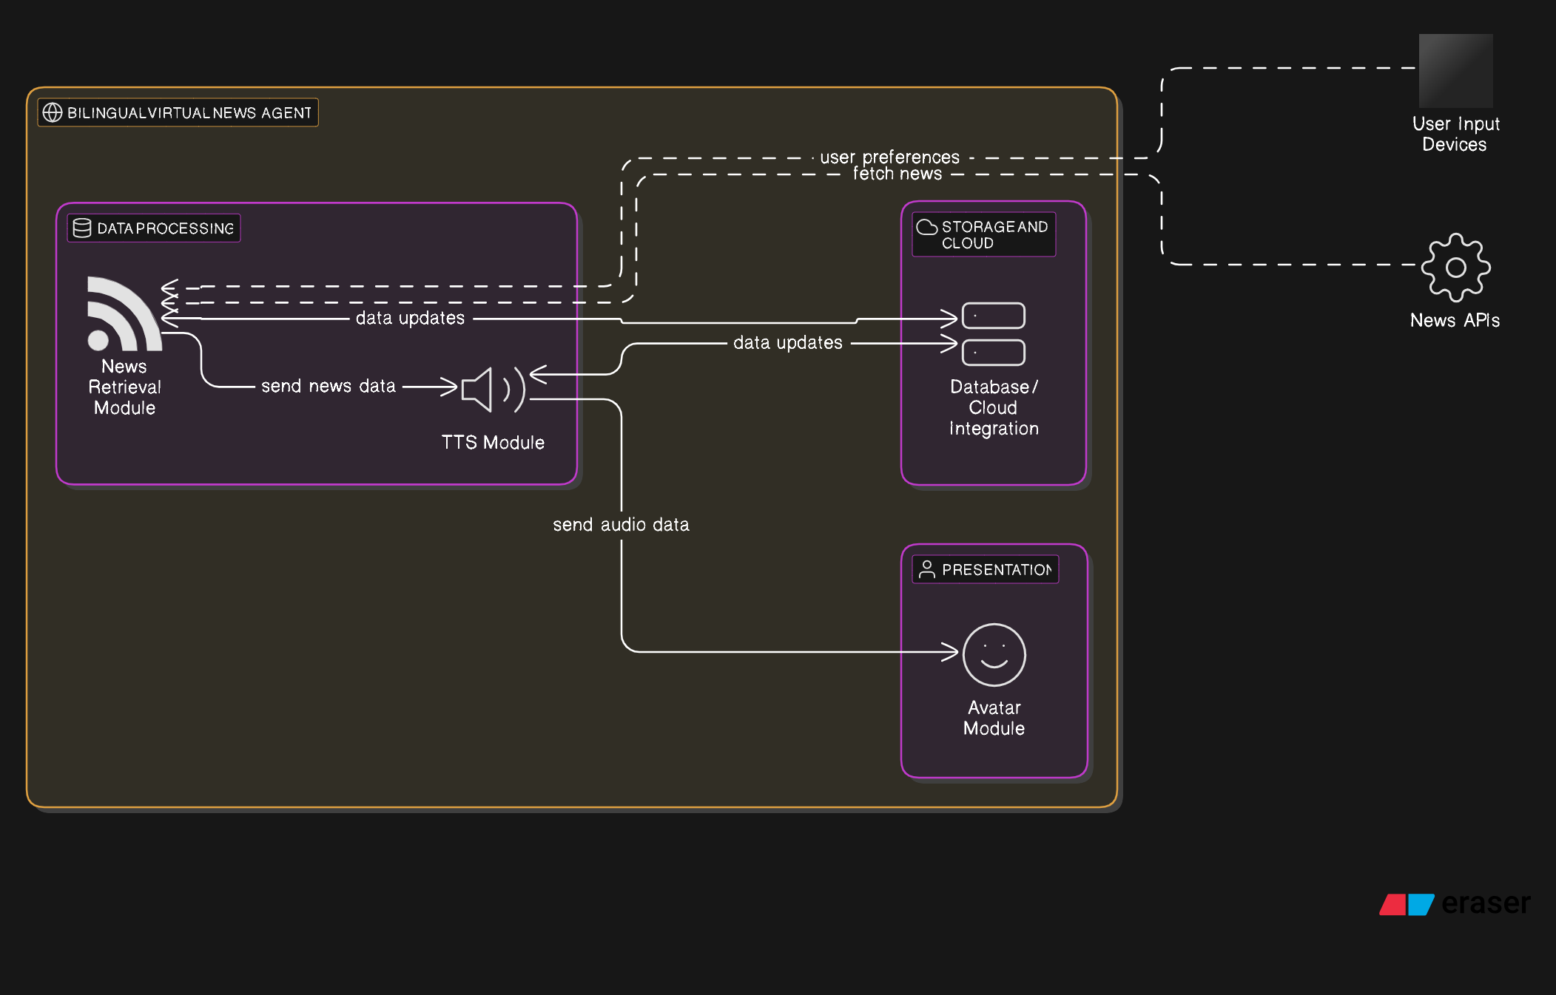

**Appendix B: Data Flow Diagram**

